* **Activity 5:**

Single-Row Subquery with More Than One Row Returned

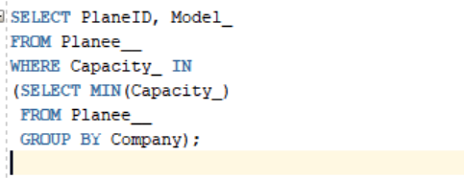

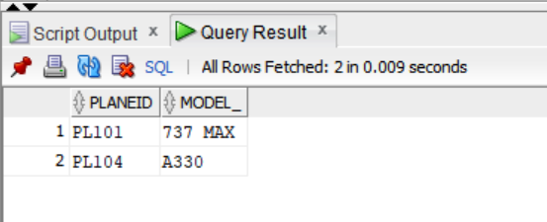OUTPUT: